Principles of Network Applications
Creating a network application involves writing programs that run on end systems (like user devices and servers) and communicate over a network. The key principles are:
- End-System Focus: Application software is written only for end systems (e.g., browsers on user devices, server programs in data centers). You do not write software for network-core devices like routers or switches, as they operate at lower network layers and are not involved in application logic.
- Communication is Key: The core function is enabling programs on different hosts to exchange messages. Communication for a network application takes place between end systems at the application layer. For example:
  - A web browser (client program) communicates with a web server program.
  - A Netflix app on your phone communicates with a Netflix server program.
- Rapid Development: This design, where application functionality is confined to end systems, allows for the fast creation and deployment of new network applications without needing to change the network core.
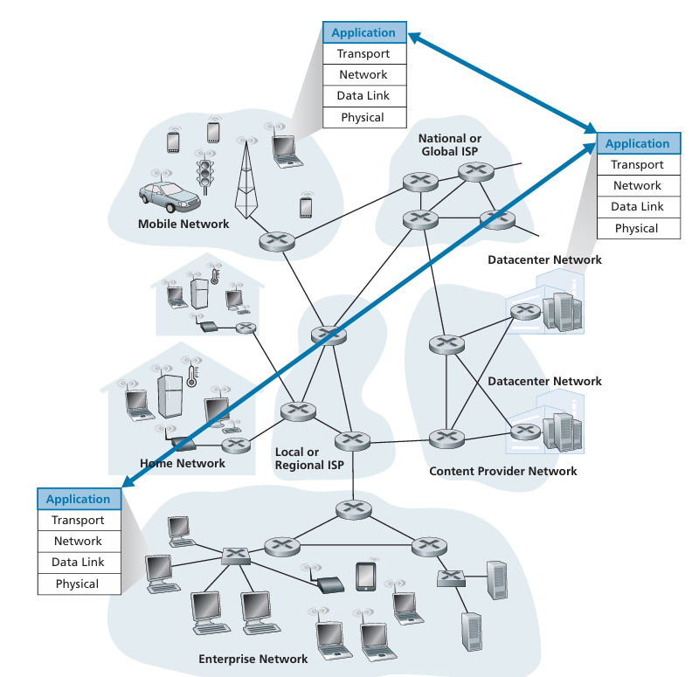

Network Application Architectures/Paradigms
An application's architecture is a high-level blueprint for how it is structured across end systems. This is separate from the fixed network architecture (like the Internet's layers). Developers choose between two main paradigms:

1. Client-Server Architecture
- Structure: Features an always-on server that services requests from multiple clients.
- Key Characteristics:
  - Clients do not communicate directly with each other.
  - The server has a fixed, well-known IP address.
  - Examples: Web (HTTP 80), FTP (21), email (SMTP 25).
- Scaling: To handle high demand, a single server is often replaced by a large, powerful data center housing hundreds of thousands of servers (e.g., Google, Facebook). This requires significant infrastructure and bandwidth costs.

2. Peer-to-Peer (P2P) Architecture
- Structure: Minimal or no dedicated servers. Instead, applications use direct communication between user devices called peers.
- Key Characteristics:
  - Peers are user-controlled devices (laptops, phones) and are not always on.
  - Self-scalability: Each peer adds demand by requesting files but also adds capacity by supplying them to others.
  - Cost-Effective: Avoids the need for massive server infrastructure.
  - Challenges: Can face issues with security, performance, and reliability due to its decentralized nature.
  - Example: BitTorrent.
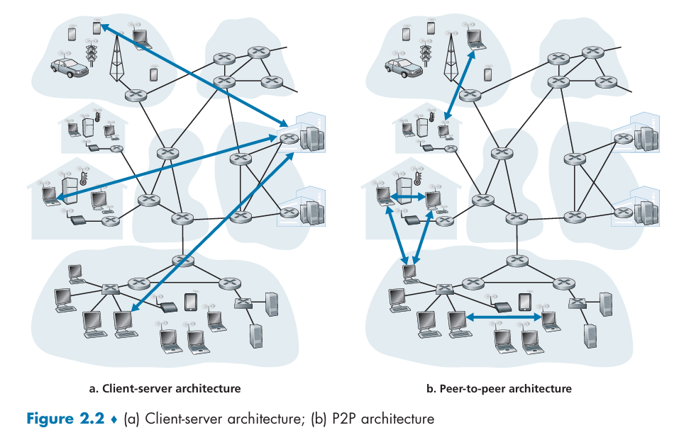

Processes
In networking, communication happens between processes, which are simply programs running on end systems (like your computer or a server). While processes on the same machine communicate via local mechanisms, network applications are all about processes on different hosts exchanging messages over the network.

Client and Server Roles
Within any pair of communicating processes, one is designated the client and the other is the server.
- Client: The process that initiates the communication. It actively contacts the other process to start a session. For example, your web browser is a client when it connects to a web server.
- Server: The process that waits for a client to contact it. A web server is always waiting for requests from browsers.
A single process can act as both a client and a server, depending on the context of a specific communication session. For instance, in a peer-to-peer (P2P) file-sharing network, the peer downloading a file acts as a client, while the one uploading it is the server. i.e. BitTorrent

The Socket: A Network Interface
A socket is the software interface that a process uses to send messages into and receive messages from the network. It's the point of connection between the application layer and the transport layer.
- Analogy: A process is a house, and its socket is its door. The application developer controls the house but must rely on the existing network infrastructure (the transportation system) outside the door.
Think of it as a door for a house; a process shoves a message out its door (socket), assuming the network will transport it to the destination's door. The application developer has control over everything on their side of the socket but has limited control over the transport layer.
Socket is also referred to as the Application Programming Interface (API) between the application and the network. The application developer has control of everything on the application-layer side of the socket but has little control of the transport-layer side of the socket. The only control that the application developer has on the transport layer side is;
(1) Choosing the transport protocol (e.g., TCP or UDP).
(2) Setting a few transport-layer parameters, such as maximum buffer and maximum segment sizes.
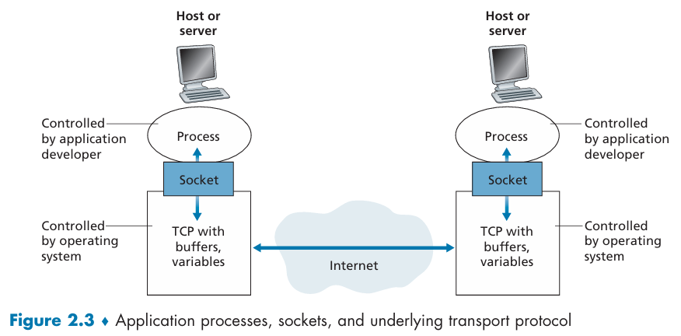

Addressing Processes
To send a message, you need a destination address. In networking, this requires two pieces of information:
- IP Address: A unique 32-bit identifier for the destination host.
- Port Number/Process Identifier: A number that specifies the particular process or socket on that host. For example, a web server usually listens on port 80, while an email server uses port 25.
Both the IP address and the port number are necessary to uniquely identify a specific process on a specific host for communication.
In summary: Communication involves a client process initiating contact with a server process by sending messages into the network via its socket. These messages are addressed to the server's IP address and specific port number.

Transport Services Available to Applications
The transport layer provides services to applications through a software interface called a socket. When you're building a network application, you have to choose a transport protocol (like TCP or UDP) based on what your application needs.

1. Reliable Data Transfer (TCP > UDP)
- What it is: Guarantees that all data sent arrives correctly and completely at the destination process.
- Needed for: Applications where data loss is devastating (e.g., email, file transfer, web documents, financial transactions).
- Not needed for: Loss-tolerant applications (e.g., conversational audio/video), where minor data loss may cause a small glitch but not a complete failure.

2. Throughput (TCP < UDP)
- What it is: The rate at which data is delivered from sender to receiver. Formula = Minimum Transmission Rate R (bps) in a link in the whole path.
- Bandwidth-Sensitive Applications: Have specific, minimum throughput requirements (e.g., Internet telephony requiring 32 kbps). They may fail or need to adapt if this throughput isn't available.
- Elastic Applications: Can use any available throughput; more is always better (e.g., email, web browsing, file transfer).

3. Timing (TCP < UDP)
- What it is: Guarantees that data will be delivered within a specified maximum delay.
- Critical for: Real-time interactive applications (e.g., telephony, video conferencing, multiplayer games) where long delays cause unnatural pauses and make the application less effective or realistic.
- Not critical for: Non-real-time applications, though lower delay is still preferred.

4. Security (TCP > UDP)
- What it is: This service is also known as Transport Layer Security (TLS). These are services that protect data being sent between processes.
- Includes: Confidentiality (encryption to prevent eavesdropping/wiretap), data integrity (ensuring data isn't altered), and authentication (verifying the identity of the sender/receiver).

Securing TCP
Neither TCP nor UDP provides any encryption—the data that the sending process passes into its socket is the same data that travels over the network to the destination process.
TCP-enhanced-with-TLS not only does everything that traditional/Vanilla TCP does but also provides critical process-to process security services, including encryption, data integrity, and end-point authentication. We emphasize that TLS is not a third Internet transport protocol, on the same level as TCP and UDP, but instead is an enhancement of TCP, with the enhancements being implemented in the application layer.
In particular, if an application wants to use the services of TLS, it needs to include TLS libraries in both the client and server sides of the application. TLS has its own socket API that is similar to the vanilla TCP socket API.
When an application uses TLS, the sending process passes cleartext data to the TLS socket; TLS in the sending host then encrypts the data and passes the encrypted data to the TCP socket. The encrypted data travels over the Internet to the TCP socket in the receiving process. The receiving socket passes the encrypted data to TLS, which decrypts the data. Finally, TLS passes the cleartext data through its TLS socket to the receiving process.
Sending Process -> TLS Socket -> TCP Socket -> Internet -> TCP Socket -> TLS Socket -> Receiving Process

Transport Services Provided by the Internet
The Internet offers two main transport protocols for applications: TCP and UDP. Choosing between them is a critical decision for application developers, as they provide different services.
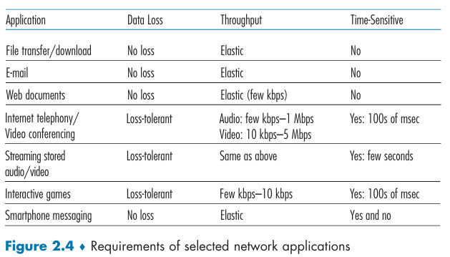

TCP Services
TCP provides two key services to applications:
- Connection-Oriented Service: Before any data is sent, TCP establishes a connection between the client and the server using a handshaking procedure. This process prepares both ends for the data transfer and ensures a full-duplex connection, allowing data to flow in both directions simultaneously.
- Reliable Data Transfer: TCP guarantees that all data sent will be received in the correct order, without any loss or duplication. If a packet is lost, TCP will re-send it. This makes TCP the ideal choice for applications where data integrity is paramount, such as email, file transfers, and web browsing.
TCP also includes a congestion-control mechanism that prevents a single application from overwhelming the network and ensures that all connections get a fair share of the available bandwidth.

UDP Services
UDP is a much simpler, "no-frills" protocol. It doesn't offer any of the guarantees that TCP does, which is why it's considered connectionless and unreliable.
- Connectionless: Unlike TCP, UDP does not perform any handshaking. The sender can simply begin transmitting data without any prior setup.
- Unreliable Data Transfer: UDP provides no guarantee that a message will reach its destination or that messages will arrive in the order they were sent. Messages can be lost or arrive out of order.
Because UDP is so lightweight and lacks congestion control, the sending application can "pump" data into the network at any rate it desires. This makes UDP particularly suitable for loss-tolerant and time-sensitive applications like online gaming, live video streaming, and Internet telephony, where speed is more important than perfect data delivery.
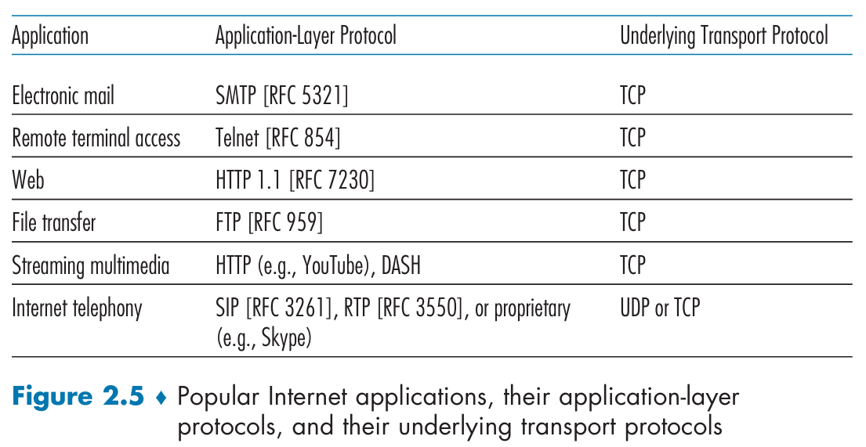

Limitations of Internet Transport Protocols
It's important to note that neither TCP nor UDP provides throughput or timing guarantees. This means there's no way to guarantee a specific data rate or a maximum delay. While this might seem problematic for real-time applications, developers have found clever ways to make these applications work reasonably well by building in resilience to deal with potential delays and loss.
Most applications choose their transport protocol based on a simple trade-off: do they need reliability or speed? Applications like file transfers and email that cannot tolerate data loss use TCP, while applications like video calls and online games that prioritize low latency and can handle some data loss use UDP.

Application-Layer Protocols
An application-layer protocol is essentially the language that two or more processes in a network application use to communicate. It's a set of rules that defines the structure, meaning, and timing of the messages they exchange.
What an Application-Layer Protocol Defines:
- Types of Messages: The kinds of messages that can be exchanged (e.g., request messages and response messages).
- Syntax of Messages: The exact format of the messages, including how fields are arranged and delimited (e.g., the structure of an HTTP request).
- Semantics of Fields: The meaning of each field in the message (e.g., a specific field in a request may indicate the requested document).
- Rules for Communication: Rules determining when and how processes send messages and respond to them (e.g., a client must send a request before a server responds).

Public vs. Proprietary Protocols:
- Public Protocols: Defined in open standards (RFCs - Request for Comments) - published by the Internet Engineering Task Force (IETF), allowing interoperability between different developers' software. Example: HTTP (for the Web).
- Proprietary Protocols: Privately owned and not publicly documented. Example: Skype’s protocols.

Protocol vs. Application:
It is vital to distinguish between an application-layer protocol and a network application:
- A network application is the entire system, including user interfaces, client/server software, data formats, and the protocol.
- An application-layer protocol is just one part of this system—the set of rules that govern communication.
Example: The Web Application
- Components: Web browsers, servers, HTML document format, and URLs.
- Application-Layer Protocol: HTTP. It defines how browsers and servers communicate but is only one piece of the larger Web application.
Example: Netflix
- Components: Video servers, client apps, billing systems.
- Application-Layer Protocol: DASH. It defines how video chunks are requested and delivered but is only one part of the larger Netflix application.

The Web and HTTP
The core appeal of the Web is that it's on-demand. Unlike traditional media like broadcast television, users can access information whenever they want it. This flexibility, combined with other key features, made it incredibly popular.

Overview of HTTP
HTTP (HyperText Transfer Protocol) is the application-layer protocol that is at the core of the Web. It is a set of rules that governs how Web clients (like your browser) and Web servers communicate with each other.

Web Objects and URLs
A Web page is made up of objects, which are simply files accessible via a single URL. An object can be an HTML file, an image, a video, or a CSS style sheet. A single Web page often consists of a base HTML file and multiple other objects that are referenced within it. For example, a page with text and five images has a total of six objects. Each object has a unique URL (Uniform Resource Locator) with two parts: the server's hostname and the object's pathname.
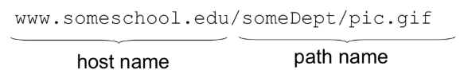

How HTTP Works
HTTP is a client-server protocol. When you want to view a web page, your browser (the client) initiates a TCP connection with the server that hosts the page's objects. This is a crucial point: HTTP relies on TCP as its underlying transport protocol.
Once the TCP connection is established, the client sends HTTP request messages to the server for each object it needs. The server then processes these requests and sends back HTTP response messages containing the requested objects.
Since HTTP uses TCP, it inherits the benefits of TCP's reliable data transfer service. This means that HTTP doesn't have to worry about lost or out-of-order messages, as TCP handles all of that. This layered approach is a key advantage of network architecture, as it allows each protocol to focus on its specific job.

Stateless Protocol
A key characteristic of HTTP is that it is stateless. This means the server does not store any information about past client requests. If the same client requests the same object repeatedly, the server will treat each request as a new, independent one and resend the object. This simplicity helps HTTP be efficient and scalable, as it doesn't have to manage state for millions of simultaneous connections.
Over the years, HTTP has evolved from its initial version, HTTP/1.0, to the more widely used HTTP/1.1 and the newer, more efficient HTTP/2. These updates have improved performance and added new features to keep up with the demands of the modern Web.

Process Flow:
- User clicks a link or enters a URL.
- Browser extracts the hostname from the URL.
- Browser establishes a TCP connection to the server.
- Browser sends an HTTP request message for the object(s) through its socket. The request message includes the path name.
- Server receives the request, retrieves the object(s), and sends an HTTP response message back through its socket.
- TCP ensures reliable delivery of all messages.
- Browser renders the received objects (e.g., displays the page).
This stateless, TCP-based request-response model ensures simplicity and reliability, forming the foundation of web communication.
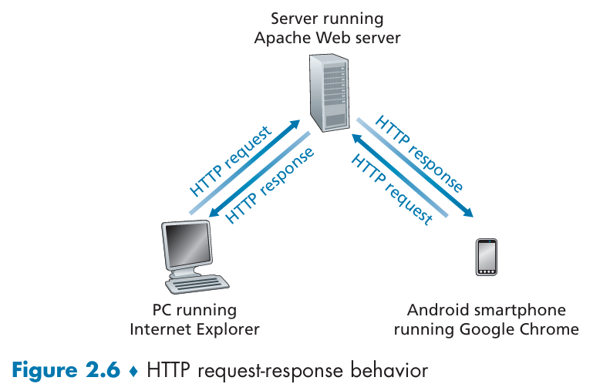

HTTP with Non-Persistent Connections
In a non-persistent connection, a separate TCP connection is established and then closed for every single object requested.
Scenario: Fetching the page that consists of a base HTML file and 10 JPEG images, and that all 11 of these objects reside on the same server.
1. The HTTP client process initiates a TCP connection to the server www.someSchool.edu on port number 80, which is the default port number for HTTP. Associated with the TCP connection, there will be a socket at the client and a socket at the server.
2. The HTTP client sends an HTTP request message to the server via its socket. The request message includes the path name /someDepartment/home .index. (We will discuss HTTP messages in some detail below.)
3. The HTTP server process receives the request message via its socket, retrieves the object /someDepartment/home.index from its storage (RAM or disk), encapsulates the object in an HTTP response message, and sends the response message to the client via its socket.
4. The HTTP server process tells TCP to close the TCP connection. (But TCP doesn’t actually terminate the connection until it knows for sure that the client has received the response message intact.)
5. The HTTP client receives the response message. The TCP connection terminates. The message indicates that the encapsulated object is an HTML file. The client extracts the file from the response message, examines the HTML file, and finds references to the 10 JPEG objects.
6. The first four steps are then repeated for each of the referenced JPEG objects.
The connection does not persist for other objects. HTTP/1.0 employes non-persistent TCP connections. Note that each non-persistent TCP connection transports exactly one request message and one response message. Thus, in this example, when a user requests the Web page, 11 TCP connections are generated.

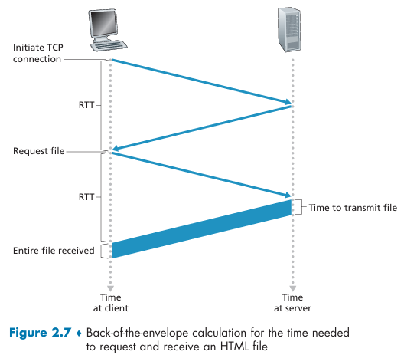
A “three-way handshake”
- The client sends a small TCP segment to the server.
- The server acknowledges and responds with a small TCP segment. (1 RTT)
- Finally, the client acknowledges back to the server.
The first two parts of the three-way handshake take one RTT. After completing the first two parts of the handshake, the client sends the HTTP request message combined with the third part of the three-way handshake (the acknowledgment) into the TCP connection. Once the request message arrives at the server, the server sends the HTML file into the TCP connection. This HTTP request/response eats up another RTT. Thus, roughly, the total response time is two RTTs plus the transmission time at the server of the HTML file.
The Problem with Non-Persistent Connections
Non-persistent connections have two major drawbacks:
- High Overhead: A new TCP connection must be established and closed for every single object requested. This requires allocating buffers and managing TCP variables for each connection, which can be a heavy burden on a server that's handling hundreds of clients simultaneously.
- Increased Latency: Each object suffers a delay of ~2 RTTs:
  - 1 RTT for the TCP handshake.
  - 1 RTT for the HTTP request/response.
(Plus the time to transmit the object.)
  - For a page with many objects, this cumulative delay can be substantial.

HTTP with Persistent Connections
Persistent connections address the inefficiencies of non-persistent connections by reusing a single TCP connection for multiple requests and responses. This is the default mode in HTTP/1.1 and later.
A single persistent connection can handle an entire web page, including the base HTML file and all of its images. Furthermore, it can even be used for multiple web pages if they are on the same server.
Key Features:
- Pipelining (in HTTP/1.1):
The client can send multiple requests back-to-back without waiting for responses to previous requests messages. The server sends multiple responses back-to-back in the same order as the requests messages.
- Timeout Closure:
The server closes the connection after a period of inactivity (configurable timeout).

Reduced Latency: Eliminates the TCP handshake overhead for subsequent requests. The first object still requires ~2 RTTs, but additional objects only require ~1 RTT each (or less with pipelining).
Performance Comparison:
- Non-Persistent: For a page with N objects, the total time is roughly ~2N RTTs (plus transmission times) if objects are fetched sequentially.
- Persistent: The total time is roughly ~2 RTTs (for the first object) + (N-1) RTTs for subsequent objects (if without pipelining). With pipelining, the time can be even lower.

HTTP Request Message Format
The message is written in ordinary ASCII text.
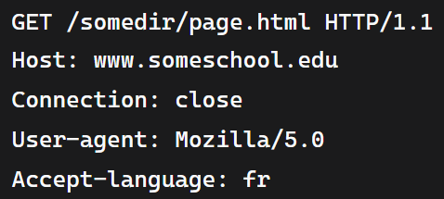
The message consists of five lines, each followed by a carriage return (\r) and a line feed (\n). The last line is followed by an additional carriage return and line feed.
The first line of an HTTP request message is called the request line; the subsequent lines are called the header lines.
1. Request Line:
- Format: [Method] [URL] [HTTP Version]
- Method: The first field is the method, which specifies the action the client wants the server to perform. Common methods include:
  - GET: The most common method, used to request an object (like a web page or an image).
  - POST: Used to submit data to the server, often from an HTML form. The data is included in the entity body of the message. It fetches specific data based on the form submitted by the user. i.e. searching something on Google.
  - HEAD: Similar to GET, but the server only sends back the response headers, not the object itself.
  - PUT: Used to upload an object to the server.
  - DELETE: Used to delete an object on the server.
- URL: The second field is the URL/pathname of the object being requested.
- Version: The third field is the HTTP version being used, such as HTTP/1.1.
2. Header Lines:
- Host: Specifies the server hosting the object.
- Connection: close: tells the server to use a non-persistent connection and close it after sending the response.
- User-agent: Identifies the client's browser or application. This helps the server tailor the content (e.g., sending a mobile-optimized version of a page).
- Accept-language: Indicates the user's preferred language for the content.
The request message can also have an entity body, which is empty for a GET request but is used with a POST request to carry data from an HTML form.
For example, when a user provides search words to a search engine. With a POST message, the user is still requesting a Web page from the server, but the specific contents of the Web page depend on what the user entered into the form fields. If the value of the method field is POST, then the entity body contains what the user entered into the form fields.

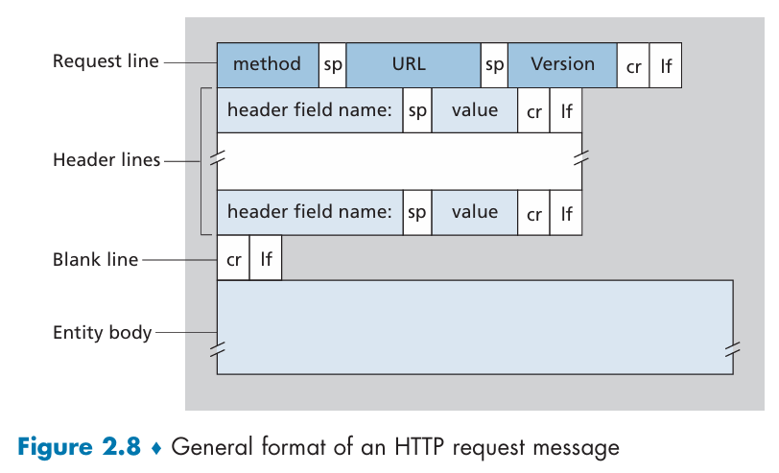

HTTP Response Message Format
It has three sections: an initial status line, six header lines, and then the entity body.
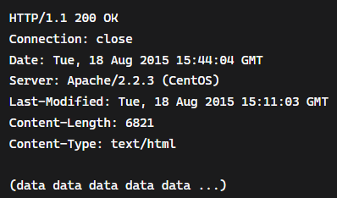
1. Status Line:
- Format: [HTTP Version] [Status Code] [Status Phrase]
- Fields:
  - HTTP Version: Protocol version.
  - Status Code: Numeric code indicating the result (e.g., 200 for success, 404 for not found).
  - Status Phrase: Human-readable description of the status.
2. Header Lines:
- Provide metadata about the response.
- Common Headers:
  - Connection: close: Indicates the connection will close after this response.
  - Date: Timestamp of the response.
  - Server: Details about the server software.
  - Last-Modified: When the resource was last changed.
  - Content-Length: Size of the response body in bytes.
  - Content-Type: Type of data in the body (e.g., text/html, image/jpeg).
3. Entity Body:
- Contains the requested object (e.g., HTML, image) for successful responses.
- For error responses, it may include a human-readable error message.

Common Status Codes
- 200 OK: The request was successful, and the object is included in the response message.
- 301 Moved Permanently: The requested object has a new, permanent URL. The new address is provided in the Location: header, and the client should automatically update its request to the new URL.
- 400 Bad Request: The server could not understand the request. This is a generic client-side error.
- 404 Not Found: A classic error, meaning the requested object doesn't exist on the server.
- 505 HTTP Version Not Supported: The server does not support the HTTP version used in the request message.

How to View a Real HTTP Response
You can use Telnet to manually send an HTTP request and see the raw response:
- Open a command prompt and run:

- Type the following request (press Enter twice after the last line):
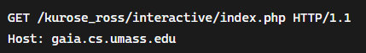
- The server will return the HTTP response message, including headers and the entity body.
To see only the headers, use the HEAD method instead of GET.

User-Server Interaction: Cookies
While an HTTP server is stateless—meaning it doesn't remember a client from one request to the next—websites often need to identify users to provide personalized services. This is where cookies come in. Cookies are a technology that allows websites to keep track of a user's activity over a period of time. User has explicit control over whether or not cookies are allowed.
How Cookies Work
Cookie technology involves four main components:
- A Set-cookie header line in an HTTP response from the server.
- A Cookie header line in an HTTP request from the client.
- A cookie file stored on the user's computer, managed by their browser.
- A back-end database on the website's server.

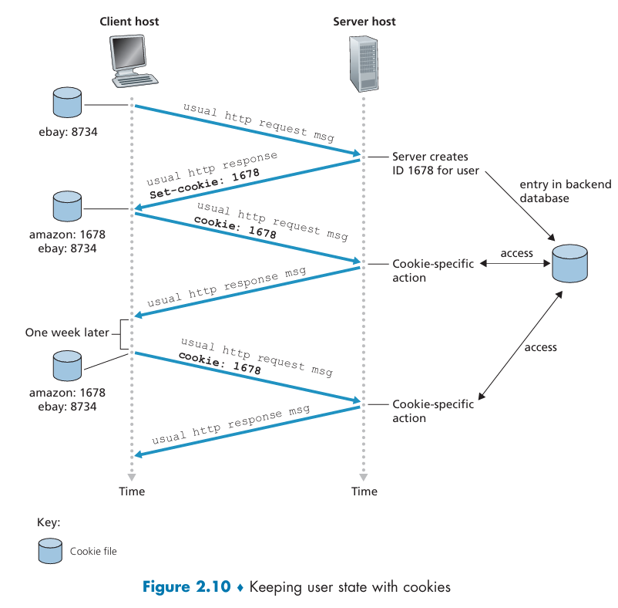
Benefits of Cookies
- Session Management: Cookies allow servers to maintain state across HTTP requests (e.g., keep users logged in during a session).
- Personalization: Websites can customize content based on user preferences (theme) and history.
- Tracking: E-commerce sites use cookies to remember shopping carts and user behavior.

Privacy Concerns
- Cookies can be used to track users across sites (e.g., via third-party cookies), raising privacy issues.
- Websites may collect and sell user data to third parties without explicit consent.
- Many browsers now block third-party cookies by default to protect user privacy.

Cookie Headers in HTTP
- Server to Client: Set-cookie: <ID> (sent in the response to initiate tracking – first time only).
- Client to Server: Cookie: <ID> (included in all subsequent requests to the same site).

Key Takeaways
- Cookies add a stateful layer to stateless HTTP, enabling user tracking and personalization.
- They are essential for functionalities like shopping carts, login sessions, and recommendations.
- However, they pose privacy risks by allowing websites to collect extensive user data.
Scenario
Here's a step-by-step example using Amazon:
- First Visit: When a user, let's call her Susan, visits Amazon.com for the first time, the Amazon server assigns her a unique identification number (e.g., 1678) and stores it in its database. The server then sends a response to Susan's browser with a Set-cookie: 1678 header.
- Browser Action: Susan's browser receives this response and saves a line in its special cookie file, associating the hostname Amazon.com with the ID 1678.
- Subsequent Visits: Every time Susan visits a new page on Amazon's site, her browser checks its cookie file. It finds the ID for Amazon and automatically includes a Cookie: 1678 header in its HTTP request.
- Server Recognition: The Amazon server receives this request, sees the Cookie header, and immediately knows that the request is coming from user 1678. It can then use this ID to track her browsing activity, remember what's in her shopping cart, and even associate the ID with her name and account information if she has registered.

Web Caching (Proxy Server)
A Web cache (or proxy server) is a network entity that stores copies of frequently requested web objects (e.g., HTML files, images) to reduce response time and bandwidth usage. It acts as an intermediary between clients and origin servers.
How Web Caching Works
Here's a step-by-step breakdown of how a Web cache works when a user requests an object:
- Browser Check: The browser establishes a TCP connection to the Web cache and sends an HTTP request for an object to the Web cache.
- Cache Check: The cache checks its local storage.
- Cache Hit: If the object is found, the cache immediately sends it back to the browser within a response message.
- Cache Miss: If the object is not found, the cache acts as a client. It opens a new TCP connection to the origin server and requests the object.
- Store & Forward: When the origin server sends the object back, the cache stores a copy of it locally before forwarding it to the user's browser.
A cache is a unique entity because it acts as both a server (when responding to a browser) and a client (when requesting from an origin server).
Web cache can be located on multiple points between a server and a user, including local user devices (browser cache), intermediary servers like proxy servers and Content Delivery Networks (CDNs), and even on the web server itself (server-side cache).
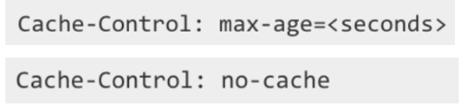
Benefits of Web Caching
Web caching has two major benefits:
- Reduced Response Time: If a requested object is in the cache, the client receives it much faster because the data doesn't have to travel all the way to the origin server and back. This is particularly beneficial when the connection between the client and the origin server is slow.
- Reduced Traffic: Caches significantly reduce the amount of traffic on an institution's access link to the Internet. For example, if a university has a 15 Mbps link and an average object size of 1 Mbps, the traffic intensity on the access link without a cache would be 1.0, which causes significant delays. With a cache that has a 40% hit rate, the traffic intensity drops to 0.6, making the delay negligible. This saves the institution the cost of upgrading its link.
Why Caches Are Deployed
- Performance: Faster response times for users.
- Cost Savings: Reduces bandwidth needs and delays infrastructure upgrades.
- Scalability: Handles high request volumes efficiently.

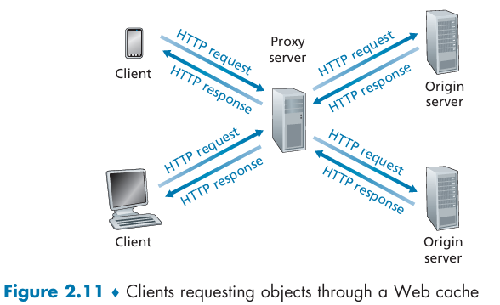
Example: Traffic Intensity = La / R
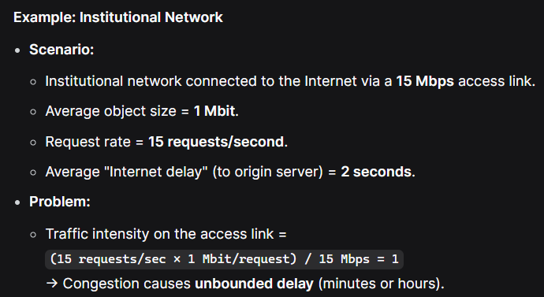
When Traffic Intensity is close to 1, the average queuing delay keeps increasing to infinity.
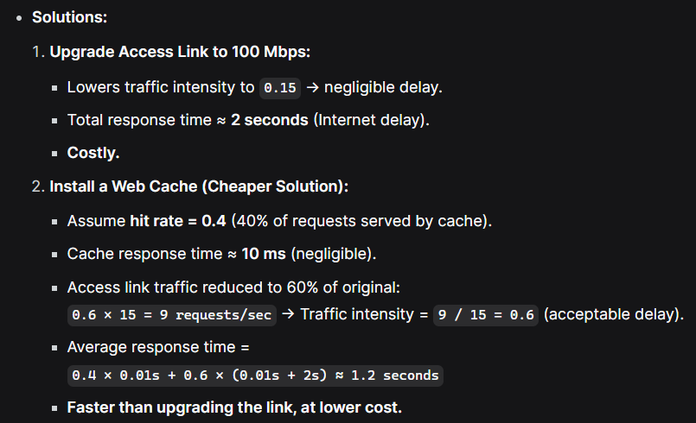
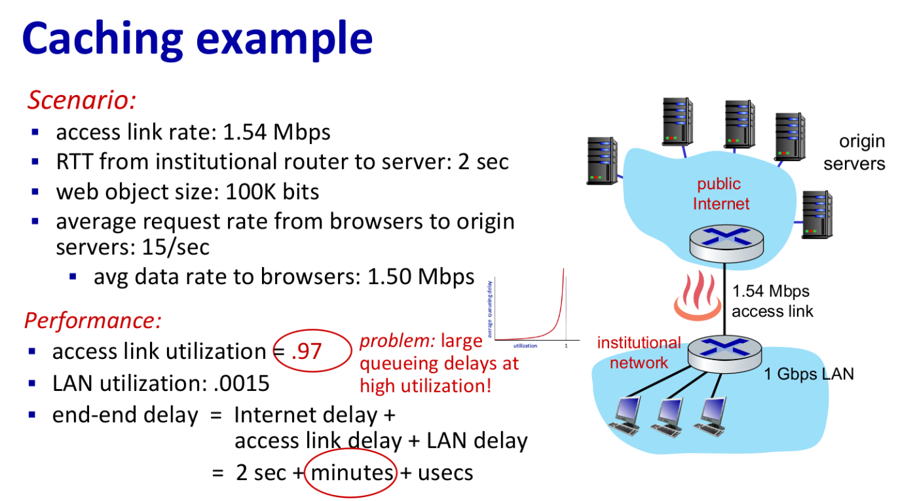
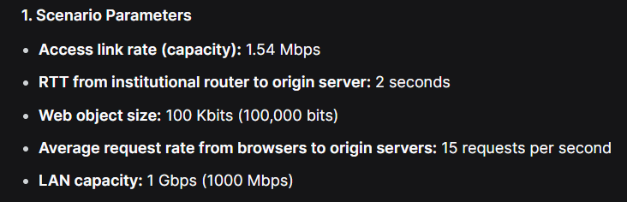
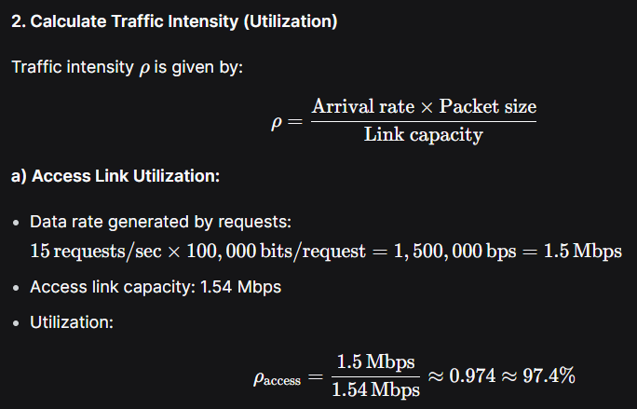
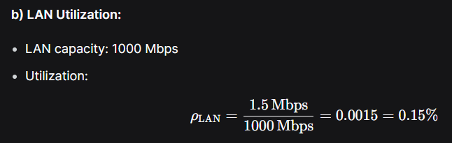

The Conditional GET
The Conditional GET is an HTTP mechanism that allows a cache (or client) to verify whether a cached object is still up-to-date with the version on the origin server. This prevents stale content from being served while minimizing unnecessary data transfer.
A Conditional GET is a special HTTP request that has two parts:
- It uses the standard GET method.
- It includes an If-Modified-Since: header line.
How Conditional GET Works
Let's follow an example with a proxy cache and a Web server:
- Initial Request: A browser requests an object, say kiwi.gif, through a proxy cache. The cache doesn't have it, so it forwards the request to the origin server.
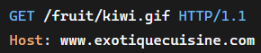
- Server Response: The origin server responds with the object and includes a Last-Modified: header, indicating when the object was last changed (e.g., Wed, 9 Sep 2015 09:23:24). The cache stores both the object and this modification date.
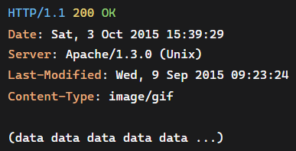
- Subsequent Request (Conditional GET): A week later, another user or browser requests the same kiwi.gif. The object is in the cache, but it might be stale. To check, the cache sends a Conditional GET request message to the origin server. This request includes the If-Modified-Since: header with the date it has stored:
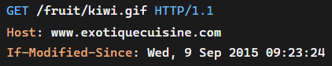
- Server Response: The server checks its version of the file.
- If the file has NOT been modified: The server sends a short response with a status code of 304 Not Modified and an empty entity body. This tells the cache that its copy is still fresh.
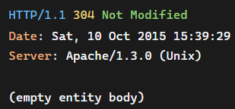
- If the file HAS been modified: The server sends a full response with a status code of 200 OK and includes the new, updated object in the entity body.
Why Conditional GET is Important
- Saves Bandwidth: Avoids transferring unchanged objects.
- Reduces Latency: A 304 response is much faster than transferring the full object.
- Ensures Freshness: Guarantees users receive updated content when changes occur.

HTTP/1.1
While HTTP/1.1's persistent connections were an improvement over non-persistent ones, they created a new problem. A browser would often open multiple parallel TCP connections to load a single web page, which helped to circumvent HOL blocking and also allowed the browser to grab more bandwidth from the network.
Head of Line (HOL) Blocking: This happens when a large object in a single TCP connection blocks the transmission of smaller objects that come after it. HTTP/1.1 server responds in-order (FCFS: first-come-first-served scheduling) to GET requests.
For example, a large video file requested at the top of a page would delay the loading of all the smaller images and scripts that follow, making the page appear slow to the user.
To get around this, browsers using HTTP/1.1 would open up to six parallel TCP connections to a single server. This allowed them to request different objects simultaneously, but it also created unnecessary overhead on the server and interfered with the intended fairness of TCP's congestion control mechanism.
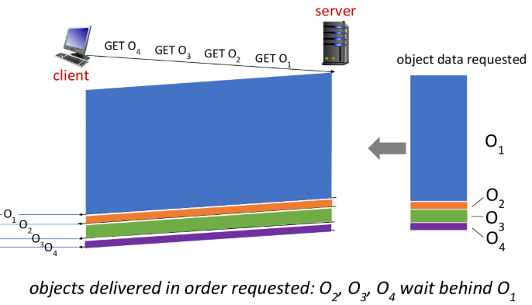
Problems with HTTP/1.1
- Head-of-Line (HOL) Blocking:
  - In HTTP/1.1, if multiple resources are requested over a single TCP connection, a large resource (e.g., a video) can block smaller resources (e.g., images) from being delivered until it is fully transmitted.
- Workaround: Browsers open multiple parallel TCP connections (typically up to 6) to bypass HOL blocking and grab more bandwidth via TCP congestion control.
- Drawbacks: This increases server load and go against fair bandwidth sharing.

HTTP/2
It retains the same HTTP methods, status codes, and headers but changes how data is formatted and transported. It decreases delay in multi-object HTTP requests.
Goals of HTTP/2
- Reduce Latency: Enable multiplexing of requests and responses over a single TCP connection.
- Request Prioritization: Allow clients to specify the priority of resources.
- Server Push: Let servers send resources to clients before they are requested.
- Efficient Header Compression: Reduce overhead with HPACK compression of headers.
HTTP/2 Solutions
1. Framing and Multiplexing
- HTTP/2 breaks messages into small frames and interleaves them over a single TCP connection – TCP Level Multiplexing.
- Example: A page with a large video (1000 frames) and 8 small objects (2 frames each):
  - Without interleaving: Small objects wait for all 1000 video frames.
  - With interleaving: Frames of small objects are sent between video frames, delivering them much sooner.
- Binary Encoding: Frames are binary (not text), making them efficient to parse and less error-prone.
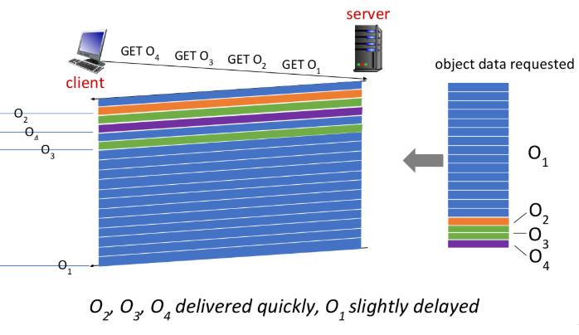
2. Request Prioritization
- Clients can assign weights (1-256) to requests to indicate priority.
- Servers can prioritize sending high-priority responses first.
- Clients can also specify dependencies between requests (e.g., CSS before images).
3. Server Push
- Servers can send additional resources (e.g., CSS, JS, images) to the client without waiting for explicit requests.
- How it works: The server analyzes the base HTML page, identifies needed resources, and pushes them proactively.
- Benefit: Reduces round-trip times and speeds up page loading.
4. Header Compression (HPACK)
- HTTP/2 compresses header fields to reduce the amount of data being transmitted.
- HTTP headers are compressed using HPACK to reduce overhead.
- Previously sent headers are stored and referenced, avoiding repetition.
Benefits of HTTP/2
- Eliminates Parallel Connections: Reduces server load and improves TCP fairness.
- Reduces HOL Blocking: Interleaving ensures smaller resources aren’t delayed by large ones.
- Faster Page Loads: Prioritization and server push optimize resource delivery.
- Less Overhead: Header compression reduces bandwidth usage.

HTTP/3
- HTTP/3 is designed to run over QUIC (a transport protocol built on UDP).
- QUIC Features:
  - Built-in multiplexing (eliminates TCP-level HOL blocking).
  - Faster connection establishment (0-RTT handshake in some cases).
  - Improved security (encryption by default).
- HTTP/3 simplifies the protocol by leveraging QUIC’s capabilities.

Electronic Mail in the Internet
It is an asynchronous communication medium, allowing users to send and receive messages at their convenience, without needing to be online at the same time.
How E-mail is Sent
The process of sending an e-mail from a sender (Alice) to a recipient (Bob) is a multi-step journey:
- Composition: Alice composes a message using her user agent (Outlook) and clicks "send."
- To Sender's Mail Server: Alice's user agent sends the message to her mail server, where it is placed in an outgoing message queue.
- To Recipient's Mail Server: Alice's mail server (acting as an SMTP client) uses SMTP to establish a TCP connection with Bob's mail server (acting as an SMTP server). The message is then transferred over this connection.
- To Recipient's Mailbox: Bob's mail server receives the message and places it in Bob's mailbox.
- Reading: When Bob next opens his user agent, it retrieves the message from his mailbox, allowing him to read it (using protocols like POP3, IMAP, or HTTP).
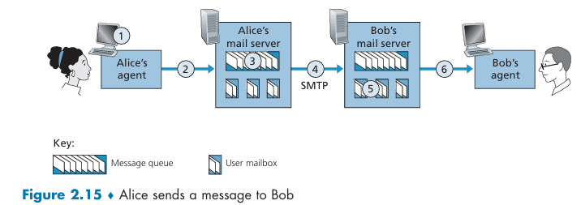

SMTP (Simple Mail Transfer Protocol)
It has some archaic characteristics, such as the restriction of message bodies to 7-bit ASCII text. This means that binary data (like images or videos) must be encoded into ASCII before being sent, and then decoded back to binary upon receipt. This is a key difference from HTTP, which does not have this restriction. SMTP is used to send emails between servers only and not the actual user agents (end users). It is a Push Protocol.
- Role: Transfers email between mail servers (not to end-users).
- Operation:
  - Uses TCP on port 25.
  - Commands and responses are text-based (like HTTP).
  - Involves a handshake, message transfer, and closure.
- Limitations:
  - 7-Bit ASCII Restriction: SMTP originally only supported plain text. To send attachments or non-ASCII content (videos or images), MIME (Multipurpose Internet Mail Extensions) is used to encode binary data as ASCII.
  - No Authentication: Original SMTP had no built-in authentication, making it vulnerable to spam. Extensions like SMTP-AUTH now add authentication.
  - No Encryption: SMTP transfers are plain text. STARTTLS is an extension to encrypt the connection.
The SMTP Handshake
SMTP operates as a client-server protocol. When a sender's mail server has a message to deliver, its SMTP client initiates a TCP connection to the recipient's mail server on port 25. Once the connection is established, the two servers engage in an application-layer "handshake" to introduce themselves and confirm the sender and recipient addresses.
The dialogue between the SMTP client (C) and the SMTP server (S) follows a set of commands and replies:
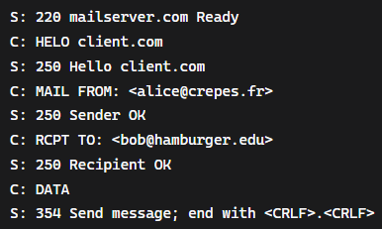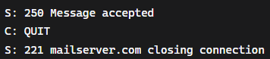
- HELO: The client introduces itself to the server.
- MAIL FROM: The client specifies the sender's e-mail address.
- RCPT TO: The client specifies the recipient's e-mail address.
- DATA: The client signals that it is about to send the message body. The server replies with a 354 code, telling the client to proceed.
- Message Body: The client sends the message text. The end of the message is indicated by a line containing only a single period (.).
- QUIT: The client requests the server to close the connection.
The server responds to each command with a three-digit reply code and an optional English message. For example, 250 indicates that the command was successful, and 221 means the server is closing the connection.

The Persistent Connection
Like HTTP, SMTP uses persistent connections. If a sending server has multiple messages to deliver to the same receiving server, it can send them all over the same TCP connection. This reduces overhead and improves efficiency. The QUIT command is only sent after all messages have been delivered, ensuring that the connection remains open for a series of transactions.
A crucial point about SMTP is that it typically uses a direct TCP connection between the sender's and recipient's mail servers. It does not use intermediate mail servers to relay messages. If the destination server is unavailable, the sender's server will simply hold the message in a queue and retry delivery later.
Key Characteristics of SMTP
- Relies on TCP: Uses port 25 for reliable data transfer.
- Text-Based Protocol: Commands and responses are in plain text (7-bit ASCII).
- Direct Server-to-Server: Establishes a direct TCP connection between the sender’s and recipient’s mail servers, without intermediate relays.
- Persistent Connections: Multiple messages can be sent over the same TCP connection.
- 7-B ASCII Restriction: Requires non-ASCII data (e.g., attachments) to be encoded (e.g., using MIME) before transmission.
Why Not Use SMTP for Retrieval?
- SMTP is designed for sending (pushing) messages between servers.
- It cannot be used for retrieving (pulling) messages from a mailbox.
- Recipients (like Bob) need a protocol to access their messages stored on the server.
- Note that Bob’s user agent can’t use SMTP to obtain the messages because obtaining the messages is a pull operation, whereas SMTP is a push protocol. Bob’s mail server cannot just push the arriving mail without bob’s user agent being online and requesting the retrieval of that mail using HTTP or IMAP. User agents are not always-on. SMTP is a "push" protocol, which means it's used to push a message from one server to another. A user's agent retrieving mail from their mailbox is a "pull" operation, which requires a different protocol like IMAP or HTTP.

Mail Message Formats
An email message consists of a header and a body, separated by a blank line. The header contains metadata (e.g., sender, recipient, subject), while the body contains the actual content. The format is defined in RFC 5322.
Header Structure
- Each header line is text-based, with a Keyword: value format.
- Required headers: From: and To:.
- Optional headers: Subject:, Date:, Cc:, Bcc:, etc.
- Headers are part of the email message itself, distinct from SMTP protocol commands.
Key Header Lines
- From:
  - Sender’s email address.
  - Example: From: alice@crepes.fr
- To:
  - Primary recipient(s).
  - Example: To: bob@hamburger.edu
- Subject:
  - Brief summary of the message.
  - Example: Subject: Meeting Tomorrow
- Date:
  - Timestamp when the message was sent.
  - Example: Date: Tue, 15 Oct 2024 10:30:00 GMT
- Cc: (Carbon Copy)
  - Secondary recipients (visible to all).
  - Example: Cc: charlie@example.com
- Bcc: (Blind Carbon Copy)
  - Hidden recipients (not visible to others).
  - Example: Bcc: diana@example.com
- Reply-To:
  - Alternate address for replies.
  - Example: Reply-To: alice.work@crepes.fr
- MIME-Version:
  - Indicates MIME encoding for attachments (e.g., MIME-Version: 1.0).

Mail Access Protocols
When an e-mail is sent from a sender's mail server to a recipient's mail server, it is placed in the recipient's mailbox. But how does the recipient actually retrieve the message? Since most users' computers and smartphones are not always on, they cannot host a mail server themselves. Instead, a user's mail is stored on a shared, always-on mail server. This brings up the question of how a user's local user agent (e.g., an e-mail app) gets messages from the remote mail server.
A user agent cannot use SMTP to retrieve mail because SMTP is a push protocol. This means that a client pushes (sends) a message to a server. To retrieve mail, the user agent needs a pull protocol, where it pulls (retrieves) the messages from the server.
Once SMTP delivers an email to the recipient's mail server, the recipient needs a way to retrieve the message from the server. This is done using mail access protocols, which are fundamentally different from SMTP because they involve pulling messages from the server (whereas SMTP is a push protocol).
There are two primary methods for a user agent to access mail from a mail server:
- Web-based E-mail (HTTP): If you're using a web-based service like Gmail, your browser acts as the user agent and uses HTTP to communicate with the mail server. The server, in this case, must have both an HTTP interface for web-based access and an SMTP interface to receive mail from other servers.
- IMAP (Internet Mail Access Protocol): For mail clients like Microsoft Outlook or Apple Mail, the IMAP protocol (defined in RFC 3501) is used to retrieve messages. IMAP is a more powerful protocol than its predecessor, POP3, as it allows you to manage mail folders, mark messages as read, delete them, and search your mailbox, all while keeping the messages stored on the server. This allows you to access your mail from multiple devices, as the messages remain synced on the server.
Both HTTP and IMAP solve the "last mile" problem of getting the e-mail from the recipient's mail server to the recipient's user agent.
How Email Delivery and Retrieval Works: Example (Alice to Bob)
- Alice sends an email:
  - Her user agent (e.g., Outlook) uses HTTP to send the message to her mail server.
- Relaying to Bob’s server:
  - Alice’s mail server uses SMTP to forward the message to Bob’s mail server.
- Bob retrieves the email:
  - Bob’s user agent (e.g., Gmail app) uses HTTP or IMAP to pull the message from his mail server.

Why Use Two Steps (Relaying)?
- Alice’s user agent does not send directly to Bob’s mail server because:
  - Reliability: If Bob’s server is down, Alice’s server can retry later (every 30 minutes).
  - Fallback: Alice can check her sent folder or get notifications if delivery fails.
- Without relaying, Alice’s user agent would have no way to handle temporary failures.

DNS—The Internet’s Directory Service
The Domain Name System (DNS) is a critical Internet service that translates/maps human-friendly hostnames (e.g., www.google.com) into machine-readable IP addresses (e.g., 172.217.164.100). It acts as the Internet’s phonebook, allowing users to access resources by name rather than numerical address.
- Hostnames are human-friendly names that are easy to remember and type. They are not designed to convey a host's location and can be a variable length, which makes them difficult for routers to process efficiently.
- IP Addresses are a different kind of identifier. They are a series of numbers, typically four bytes long, separated by periods (e.g., 121.7.106.83). They have a rigid, hierarchical structure. As you read the numbers from left to right, they become more and more specific, just like a postal address goes from country to city to street. This structure provides a router with the exact information it needs to find a host on the network.
Because routers use IP addresses for routing packets, there must be a way to translate a hostname into its corresponding IP address. This is the primary function of the DNS (Domain Name System), which acts as the Internet's directory service.
Like HTTP, FTP, and SMTP, the DNS protocol is an application-layer protocol since it (1) runs between communicating end systems using the client-server paradigm and (2) relies on an underlying end-to-end transport protocol to transfer DNS messages between communicating end systems.

Services Provided by DNS
DNS is not a single entity but a massive, distributed database implemented across a hierarchy of servers. Routers and other network devices need a structured, numerical address called an IP address (e.g., 172.217.14.78) to route traffic. It includes an application-layer protocol that allows a host to query this database for information. Beyond this primary function, DNS provides several other services.
How DNS Works: Example (Browser Request)
- User enters www.someschool.edu/index.html in a browser.
- Browser extracts hostname (www.someschool.edu) and passes it to the DNS client.
- DNS client sends a query to a DNS server.
- DNS server looks up the hostname in its database and sends back the corresponding IP address.
- Once the browser receives the IP address, it initiates a TCP connection to the IP address on port 80 (HTTP).
This process adds a small delay, but this is often minimized because DNS servers cache frequently requested IP addresses, reducing the need to query higher-level servers repeatedly.
Other Services Provided by DNS
Beyond simple name-to-address translation, DNS provides several other critical services:
- Host Aliasing: DNS allows a complex, canonical hostname (e.g., relay1.west-coast.enterprise.com) to have more memorable aliases (e.g., enterprise.com or www.enterprise.com). DNS can provide a host's canonical hostname and IP address when given an alias.
- Mail Server Aliasing: This is a specific type of aliasing for mail servers. It allows a mail server to have a simpler, more user-friendly name, which can even be the same as the company's website hostname (e.g., both a website and a mail server can be yahoo.com).
- Example:
  - Email address: bob@yahoo.com (simple alias).
  - Actual mail server: relay1.west-coast.yahoo.com (canonical name).
  - DNS uses MX (Mail Exchanger) records to map email domain names to mail server IP addresses.
- Load Distribution: DNS is used to distribute traffic among multiple, replicated servers. DNS associates one alias hostname with multiple IP addresses for replicated servers. A busy website like cnn.com is hosted on many servers, each with a different IP address. When a client queries DNS for cnn.com, the DNS server provides the list of all associated IP addresses but rotates the order for each request. This simple rotation helps balance the traffic evenly across all the servers.
The DNS database contains this set of IP addresses. When clients make a DNS query for a name mapped to a set of addresses, the server responds with the entire set of IP addresses, but rotates the ordering of the addresses within each reply. Because a client typically sends its HTTP request message to the IP address that is listed first in the set, DNS rotation distributes the traffic among the replicated servers. DNS rotation is also used for e-mail so that multiple mail servers can have the same alias name.

Overview of How DNS Works
The Problems with a Centralized DNS
- Single Point of Failure: If the single DNS server were to crash, the entire Internet would effectively stop working. No one could translate hostnames to IP addresses, so applications like web browsers and e-mail clients would fail to connect to their destinations. This is a massive risk for a system as critical as the Internet.
- Traffic Volume: Imagine a single server handling all DNS queries from every Internet user in the world. The traffic volume would be astronomical, overwhelming the server and its network connection. This would make the server a constant bottleneck and cause significant delays for everyone.
- Distant Centralized Database: A single server can't be geographically close to every user. If the server is in New York, a query from someone in Australia would have to travel across the globe, adding seconds of delay to every single application request. This is unacceptable for a system that needs to be fast and responsive.
- Maintenance: Maintaining a database with every single hostname-to-IP-address mapping on the Internet would be a monumental task. Every time a new host is added or an IP address changes, the database would need to be updated. The sheer size of the database and the constant updates would make it incredibly difficult to manage.

A Distributed, Hierarchical Database
DNS is distributed and hierarchical to handle the scale of the Internet. It consists of three main types of servers organized in a hierarchy: root DNS servers, top-level domain (TLD) DNS servers, and authoritative DNS servers. Additionally, local DNS servers (resolvers) play a key role in query resolution.
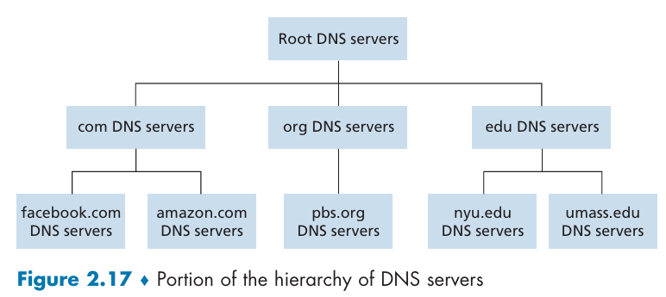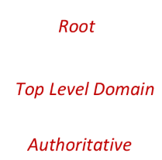
Client wants IP address for www.amazon.com:
- client queries root server to find .com DNS server
- client queries .com DNS server to get amazon.com DNS server
- client queries amazon.com DNS server to get IP address for www.amazon.com
The DNS Server Hierarchy
- Root DNS Servers: At the very top of the hierarchy, these servers hold the addresses of all the Top-Level Domain (TLD) servers. There are many instances of these root servers located around the globe to handle traffic and prevent a single point of failure.
- Top-Level Domain (TLD) Servers: These servers manage specific top-level domains like .com, .org, .edu, and all country-specific domains like .uk or .fr. A TLD server knows the addresses of the authoritative DNS servers for all domains within its TLD (e.g., the .com TLD server knows about amazon.com, google.com, etc.).
- Authoritative DNS Servers: This is the final and definitive stop. An organization's authoritative DNS server contains the actual hostname-to-IP-address mappings for all the publicly accessible hosts within that organization's domain (e.g., the authoritative server for amazon.com knows the IP address of www.amazon.com). Every organization with an online presence must have an authoritative DNS server.
- Local DNS Server: Although not part of the main hierarchy, the local DNS server is a critical part of the process. Every Internet Service Provider (ISP) and institution (like a university) maintains a local DNS server that is close to its users. It acts as a proxy and is the first place a host sends a DNS query.
How a DNS Query Works
Let's trace a query from a user at cse.nyu.edu who wants to find the IP address for gaia.cs.umass.edu.
- Query Initiation: The user's host first sends a DNS query to its local DNS server, dns.nyu.edu. The local DNS server doesn't know the IP address for gaia.cs.umass.edu.
- Local DNS Server Actions: Acting as a client, the local DNS server sends the query to a root DNS server.
- Iterative Queries to Hierarchy:
  - The root server doesn't know the full address either, but it knows the addresses of the TLD servers for the .edu domain. It sends a reply back to the local DNS server with a list of those addresses.
  - The local DNS server then sends the query to one of the .edu TLD servers.
  - The .edu TLD server knows about all of the educational institutions' domains. It finds the entry for umass.edu and replies with the address of the authoritative DNS server for the University of Massachusetts, dns.umass.edu.
  - Finally, the local DNS server sends the query directly to dns.umass.edu, which is the authority for the umass.edu domain. This server has the IP address for gaia.cs.umass.edu and returns it in a reply.
- Response to Client: The local DNS server receives the final IP address and forwards it to the original requesting host at cse.nyu.edu. The entire process is now complete.
Total Messages: 8 (4 queries + 4 replies) without caching.
In this example, the initial query from the host to its local DNS server is a recursive query because the host asks the local server to handle the entire lookup for it. The subsequent queries from the local DNS server to the root, TLD, and authoritative servers are iterative queries, where each server simply points the local server to the next server in the chain.
The whole process seems lengthy, but in practice, DNS caching (where servers temporarily store recently found IP addresses) makes it incredibly fast, often taking mere milliseconds.
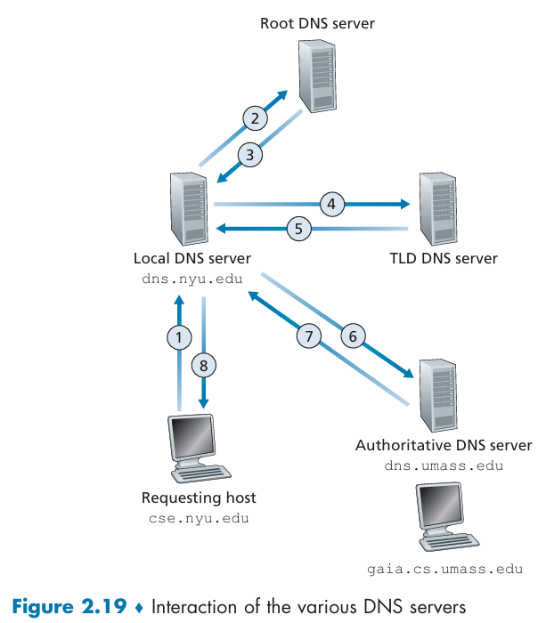

DNS Cache
DNS caching is the process of temporarily storing DNS query results on a server's local memory. The concept is simple: when a DNS server (of any type) receives a reply containing a hostname-to-IP address mapping, it saves that information for a specific amount of time, known as its Time-to-Live (TTL).
- Reduces Delay: If a user on the same network or even the same computer queries for a hostname that's already in the local DNS server's cache, the server can immediately provide the IP address without having to go through the long, multi-step query process involving root, TLD, and authoritative servers. This drastically reduces the resolution time, leading to faster web page loading.
- Minimizes Network Traffic: By answering queries from its cache, the local DNS server eliminates the need to send messages to other servers on the Internet. This reduces overall network traffic and lessens the load on the higher-level DNS servers, particularly the root servers, which are rarely queried in practice because their information is so widely cached.
- Bypassing the Hierarchy: Caching allows a local DNS server to bypass the entire hierarchy. For example, once your local DNS server has queried for cnn.com and received its IP address, it will store that information. The next time anyone on your network asks for cnn.com, the local server can skip the entire chain of queries and respond immediately from its cache.
The TTL value for a DNS record is determined by the domain's administrator. Each DNS record has a TTL (typically set by the authoritative server) that specifies how long the record can be cached.
When the TTL expires, the cached record is discarded, forcing the DNS server to perform a new lookup to ensure it has the most up-to-date information. This prevents clients from using outdated IP addresses if a website has moved to a new server.

DNS Records and Messages
the DNS is a massive distributed database, but what exactly is stored in this database? The answer is resource records (RRs). These are four-field tuples that contain all the information needed for the DNS to function.
Resource Record (RR) Format
Every DNS resource record is a four-tuple: (Name, Value, Type, TTL)
- Name: The name of the host or domain the record is for.
- Value: The value associated with the name, which changes depending on the Type.
- Type: Specifies the kind of data in the record. This is a critical field.
- TTL (Time-to-Live): The amount of time (in seconds) that a record should be cached by a DNS server. Once this time expires, the server must discard the record and perform a new query to get fresh information.
The name will be mapped to its value. i.e. youtube.com -> exp.rt.youtube.com (CNAME) or youtube.com -> 192.258.184.13 (A).
Key DNS Record Types
The Type field defines the purpose of the record. Here are four of the most common types:
- Type A: This is the most basic and common record type. It provides the standard hostname-to-IP address mapping.
  - Example: (relay1.bar.foo.com, 145.37.93.126, A, TTL) tells a DNS server that the hostname relay1.bar.foo.com can be found at the IP address 145.37.93.126.
- Type NS (Name Server): This record is used to route DNS queries through the hierarchy. It identifies the TLD and authoritative DNS server for a specific domain.
  - Example: URL: foo.com/
  - Root Server: (.com, TLD Server IP, NS, TTL) tells the local DNS server that .com domains reside in XXX (TLD Server IP) TLD server.
  - TLD Server: (foo.com, dns.foo.com, NS, TTL) tells local DNS server that dns.foo.com is the authoritative server for the foo.com domain.
- Type CNAME (Canonical Name): This record provides a canonical hostname for a given alias hostname. It's used to allow hosts to have multiple, more memorable names.
  - Example: (www.foo.com, relay1.bar.foo.com, CNAME, TTL) means that www.foo.com is just an alias for the canonical hostname relay1.bar.foo.com.
- Type MX (Mail Exchanger): This record is specifically for mail servers. It provides the canonical hostname of a mail server for a given alias hostname. This allows a company's mail and web servers to share the same alias name.
  - Example: (foo.com, mail.bar.foo.com, MX, TTL) tells a mail client that mail for foo.com should be sent to the mail server located at mail.bar.foo.com.
An authoritative DNS server will contain Type A, CNAME, MX records for its own hosts, while TLD or root servers will primarily contain Type NS records to point queries to the next server in the hierarchy.

DNS Message
We know what information is stored in DNS records, let's now look at how that information is packaged into DNS messages. There are only two types of DNS messages—queries and replies—and they both share the exact same format.
DNS Message Structure
Every DNS message consists of a header and four distinct sections that follow it:
- Header Section: This is a fixed 12-byte section containing crucial metadata. It includes:
  - Identification: A 16-bit number that helps match a reply to its original query.
  - Flags: A field with various 1-bit flags that provide important information, such as whether the message is a query or a reply, if the server is authoritative for the domain, and whether the client wants the server to perform recursion on its behalf.
  - Number of Fields: Four fields that indicate how many records are present in the following four sections.
- Question Section: This section contains the actual query. It includes the name being queried (e.g., www.google.com) and the type of record being requested (e.g., A for an IP address, MX for a mail server).
- Answer Section: In a reply message, this is the most important section. It contains the resource records (RRs) that directly answer the query. For example, a reply to a Type A query for www.google.com would have a Type A record containing its IP address in this section. A single answer can contain multiple RRs if a hostname has multiple IP addresses (for load balancing, for example).
- Authority Section: This section lists other authoritative DNS servers. For instance, in a reply from a .com TLD server, this section would contain the names of the authoritative servers for the domain you're trying to reach (e.g., the authoritative servers for google.com).
- Additional Section: This section contains other helpful RRs. A great example is when a query is made for a mail server's MX record. The answer section would give the canonical name of the mail server, while the additional section would conveniently provide the Type A record for that same canonical name, including the IP address. This saves the client from having to make another query to get the IP address.

